National Public Health Week (#NPHW)
✔ “What actions did you take toward public health advocacy to honor NPHW?”
✔ “How does recognizing NPHW raise awareness about public health issues, and how can we capitalize on this initiative?”
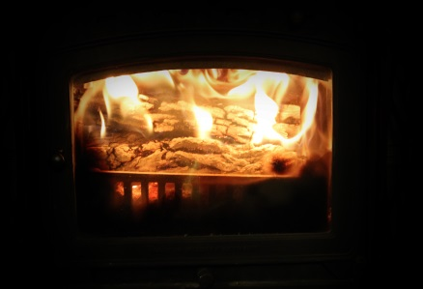
✔ “What drives you to study/work in public health? #WhyPublicHealth?”

Join us for our Public Health Fireside Chat, a forum for students and professionals to informally consult and discuss issues related to hot topics within public health, to share about challenges and victories working in public health, and to build community as students at UNE. Grab your favorite blanket, a cup of coffee or hot chocolate, and your computer and join us online!
Thursday, April 20, 2017
8:00pm EDT
Join online:
https://zoom.us/j/771726553
Join by phone:
Phone: 408-638-0968
Meeting ID: 771 726 553

