National Public Health Week (#NPHW)

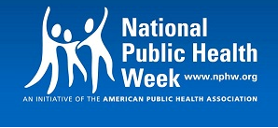

There are many challenges and threats facing public health and healthcare in general in the United States right now. What can you do to be an advocate for public health? Join UNE APHA Student Assembly for a webinar on getting engaged with your representatives and local media to raise awareness and advocate for public health in your local area.

Thursday, April 6, 2017
8:00pm EDT
Join online:
https://zoom.us/j/150141327

Join by phone:
Phone: 408-638-0968
Meeting ID: 150 141 327

