All About APHA-SA
✔ “Are you a member of APHA-SA? If so, what do you find to be most beneficial?”
✔ “Are you going to APHA’s Annual Meeting & Expo this year? Have you submitted a poster proposal? Why do you think ‘Climate Changes Health’ is the theme this year? Do you believe that is the most pressing issue in public health?”
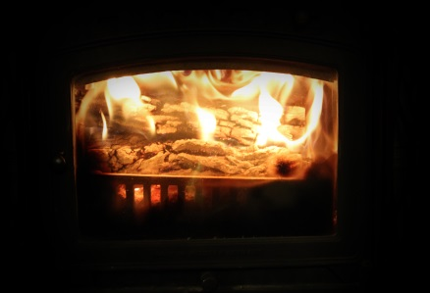
✔ “What are the plans for UNE APHA-SA this upcoming academic year? Who will be on the board?”

Join us for our Public Health Fireside Chat, a forum for students and professionals to informally consult and discuss issues related to hot topics within public health, to share about challenges and victories working in public health, and to build community as students at UNE. Grab your favorite blanket, a cup of coffee or hot chocolate, and your computer and join us online!
Thursday, August 17, 2017
8:00pm EDT
Join online:
https://zoom.us/j/771726553
Join by phone:
Phone: 408-638-0968
Meeting ID: 771 726 553

