National Safety Month (#NSM)
✔ “Do you think efforts to tackle distracted driving have been effective thus far? What other tactics could public health professionals use to tackle distracted or fatigued driving?”
✔ “What are the ergonomic conditions where you spend most of your time (work, school, etc)? Are you able to walk around/stand to promote healthy ergonomics?”
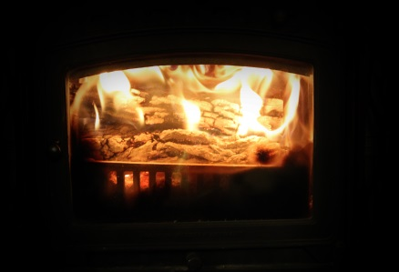
✔ “What demographic of risk is most interesting to you? How do you want to use your work in public health to reduce injury risk in that population?”

Join us for our Public Health Fireside Chat, a forum for students and professionals to informally consult and discuss issues related to hot topics within public health, to share about challenges and victories working in public health, and to build community as students at UNE. Grab your favorite blanket, a cup of coffee or hot chocolate, and your computer and join us online!
Thursday, June 22, 2017
8:00pm EDT
Join online:
https://zoom.us/j/771726553
Join by phone:
Phone: 408-638-0968
Meeting ID: 771 726 553

