Maine Center for Disease Control (Maine CDC) & Maine Department of Agriculture, Conservation & Forestry’s Animal Health Division (Maine DACF DAPH)  Employment Application for Internship | 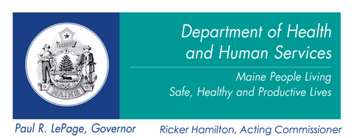

Applicant Information
Last Name |  |  |  |  |  |  |  |  |  | First |  |  |  |  |  |  |  |  |  | M.I. |  | Date
Street Address |  |  |  |  |  |  |  |  |  |  |  |  |  |  |  |  |  |  |  | Apartment/Unit #
City |  |  |  |  |  |  |  |  |  | State |  |  |  |  |  |  |  |  |  | ZIP
Phone |  |  |  |  |  |  |  |  |  | E-mail Address
Are you a citizen of the United States? |  |  |  |  |  |  |  | YES | NO |  |  | If no, are you authorized to work in the U.S.? |  |  |  |  |  |  |  |  |  |  |  | YES |  | NO
Have you ever been convicted of a felony? |  |  |  |  |  |  |  | YES | NO |  |  | If yes, explain

Education
High School |  |  |  |  |  |  |  |  | Degree
From |  |  |  |  | To |  | Did you graduate? |  |  |  | YES |  | NO |  |  |  |  | If no, do you anticipate graduating?
College |  |  |  |  |  |  |  |  | Degree
From |  |  |  |  | To |  | Did you graduate? |  |  |  | YES |  | NO |  |  |  |  | If no, do you anticipate graduating?
Major |  |  |  |  |  |  |  |  | Minor(s)
Other School |  |  |  |  |  |  |  |  | Degree
From |  |  |  |  | To |  | Did you graduate? |  |  |  | YES |  | NO |  |  |  |  | If no, do you anticipate graduating?

References
Please list two professional references (Teachers are acceptable)
Full Name |  |  |  |  |  |  |  |  |  |  |  |  |  | Relationship
Company |  |  |  |  |  |  |  |  |  |  |  |  |  | Phone
Address
Full Name |  |  |  |  |  |  |  |  |  |  |  |  |  | Relationship
Company |  |  |  |  |  |  |  |  |  |  |  |  |  | Phone
Address

Respond to the questions below, limiting each response to 2-4 sentences):

- Please explain why you’re interested in this internship:

- Please tell us about your work experience (volunteer activities or community service are acceptable) and explain how is it relevant to this internship.

- What skills would you like to gain from this experience? What skills can you offer us?

- What are you long-term career goals?

- Is there anything else you’d like to share with us?

