Upcoming Professional Development Webinars
Be sure to register for these free upcoming webinars!
- In Print and On Air: Get Ready to Work with the Media
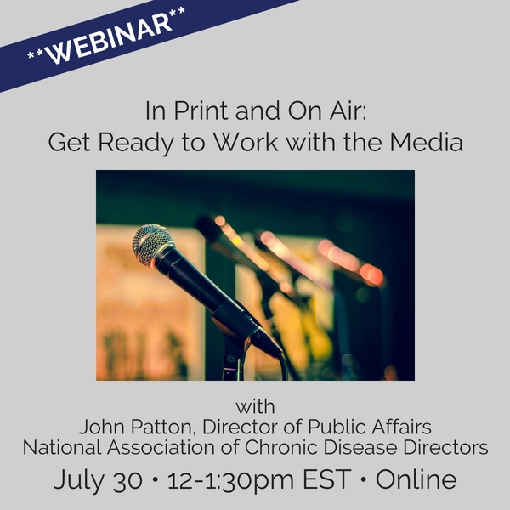
July 30, 2018
12-1:30 PM EST
Presenter: John Patton, Director of Public Affairs
National Association of Chronic Disease Directors
http://www.r4phtc.org/training-database/in-print-and-on-air/

- Becoming the Hero of Your Story: Developing and Distributing Persuasive, Resonant Messages for Your Key Audiences
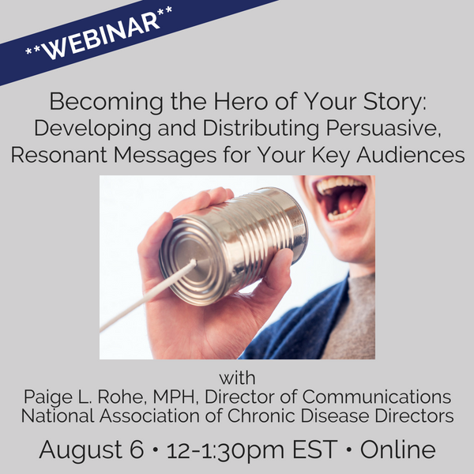
August 6, 2018
12-1:30 PM EST
Presenter: Paige L. Rohe, MPH, Director of Communications
National Association of Chronic Disease Directors
http://www.r4phtc.org/training-database/becoming-the-hero-of-your-story-developing-and-distributing-persuasive-resonant-messages-for-your-key-audiences/

